**How to delete the builds of projects using Jenkins pipeline:**

1. Got to new Item

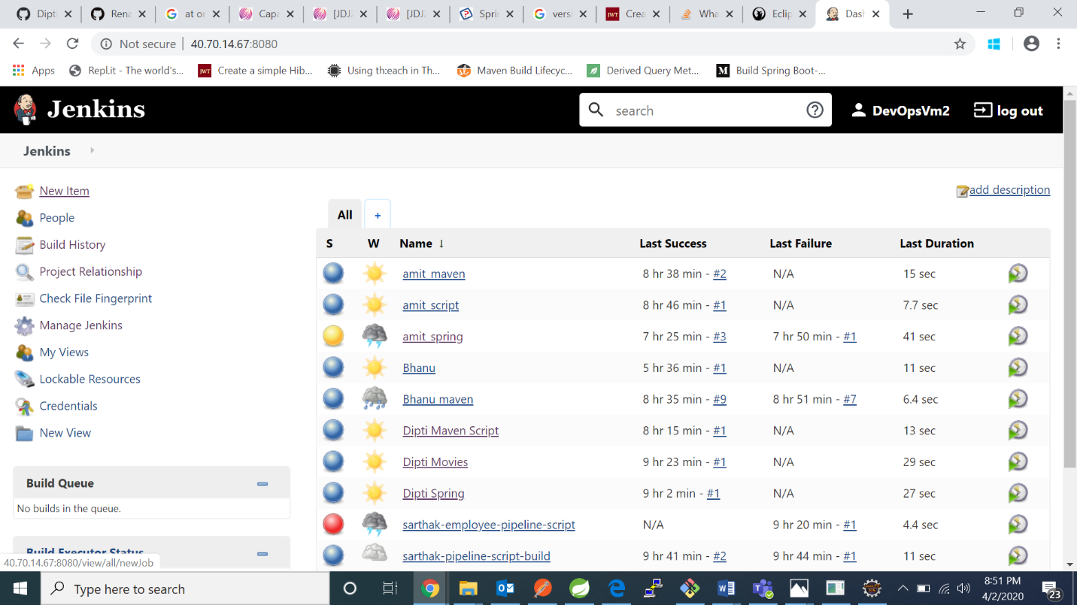

1. Create a pipeline project

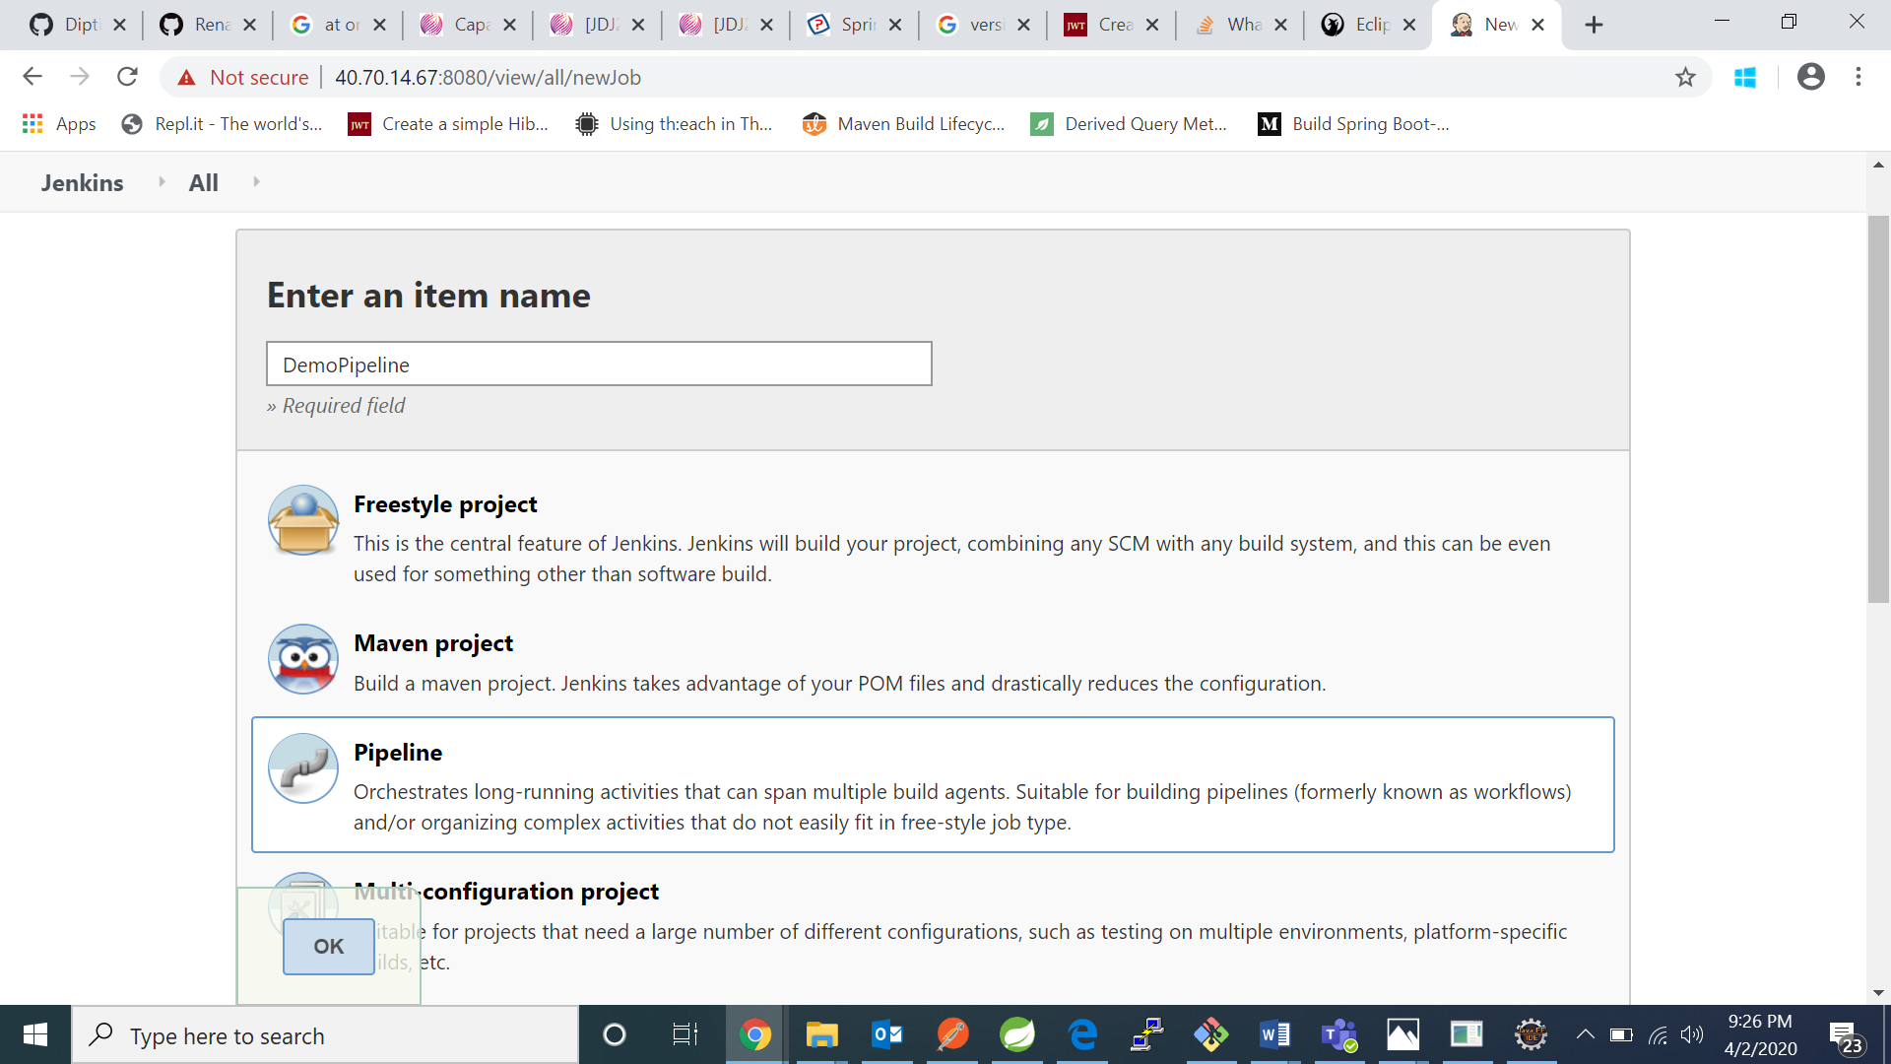

1. Go to build triggers and in schedule write in a the format:

MINUTES Minutes in one hour (0-59)

HOURS Hours in one day (0-23)

DAYMONTH Day in a month (1-31)

MONTH Month in a year (1-12)

DAYWEEK Day of the week (0-7) where 0 and 7 are Sunday.

*-stands for every time or day or month

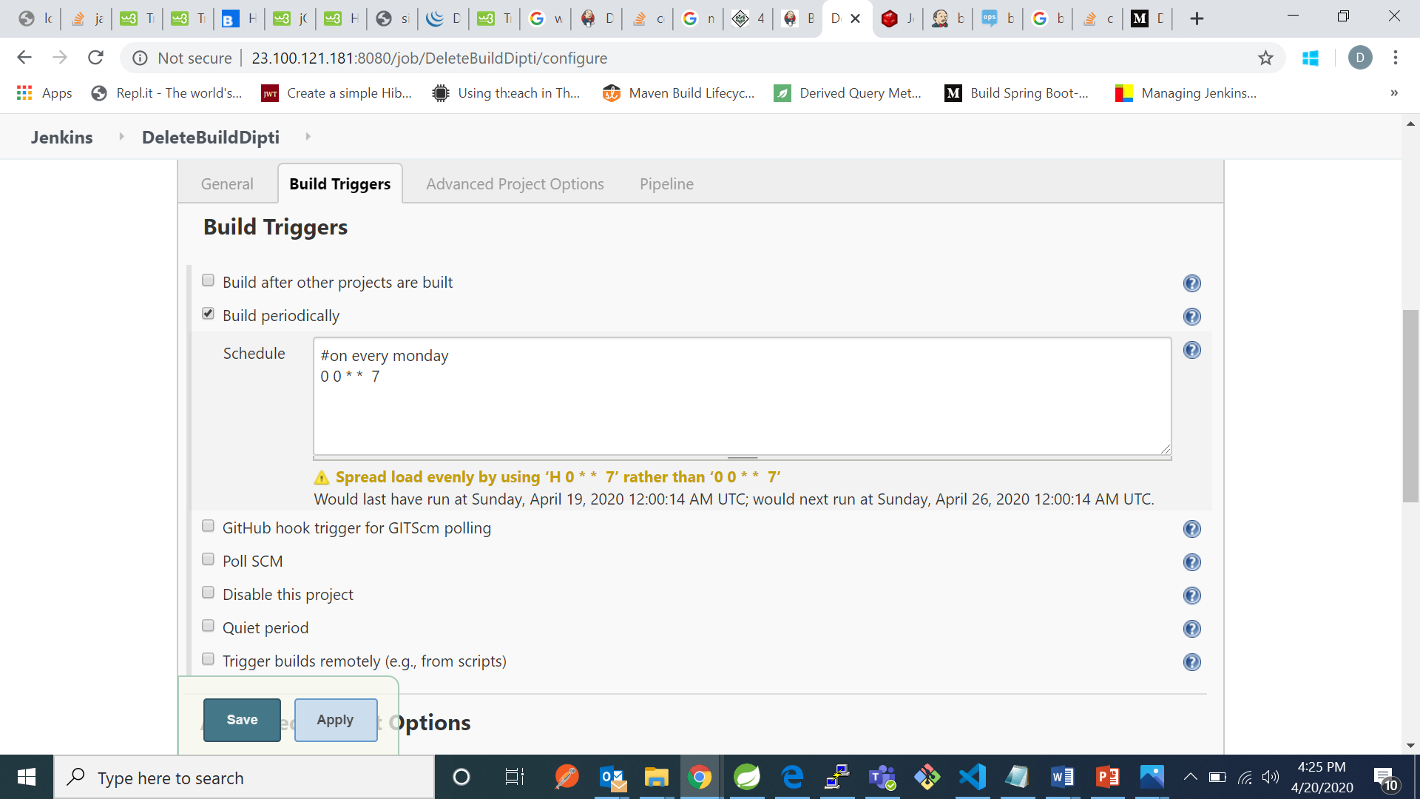

1. Go to pipeline and write down the following pipeline and uncheck use “groovy sandbox”: 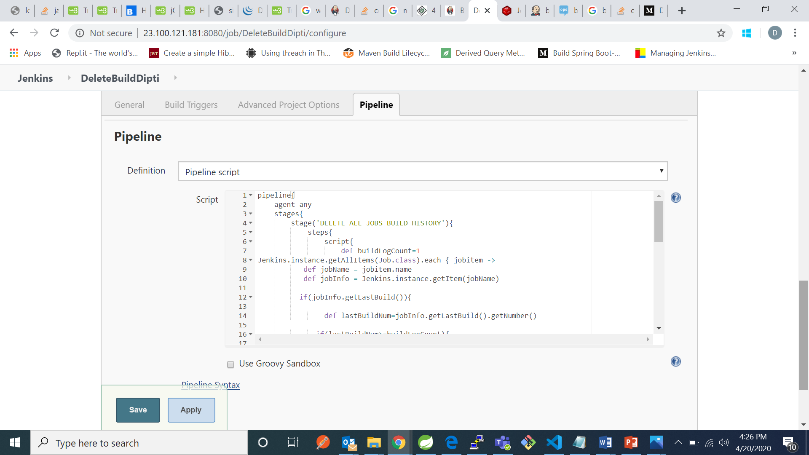

PIPELINE:

pipeline{

agent any

stages{

stage('DELETE ALL JOBS BUILD HISTORY'){

steps{

script{

def buildLogCount=1

Jenkins.instance.getAllItems(Job.class).each { jobitem ->

def jobName = jobitem.name

def jobInfo = Jenkins.instance.getItem(jobName)

if(jobInfo.getLastBuild()){

def lastBuildNum=jobInfo.getLastBuild().getNumber()

if(lastBuildNum>=buildLogCount){

def deletedBuildNum=lastBuildNum - buildLogCount

def deletedNumRange = Fingerprint.RangeSet.fromString("0-${deletedBuildNum}",false);

def buildCount=jobInfo.getBuilds(deletedNumRange).size()

if(buildCount==0){

println "No build logs found in ${jobName} and build history count is : ${buildCount}"

}

else{

jobInfo.getBuilds(deletedNumRange).each { item ->

item.delete()

}

}

}

else{

println "No build logs to delete in ${jobName}"

}

}

else{

println "No build logs found in ${jobName}"

}

}

}

}

}

}

}

The no which you specify in the “def buildLogCount” will be remaining latest builds.

If I mention it as 0 --🡪 it will delete all builds of the project built recently.

***If you check the “use groovy sandbox” you may get error:

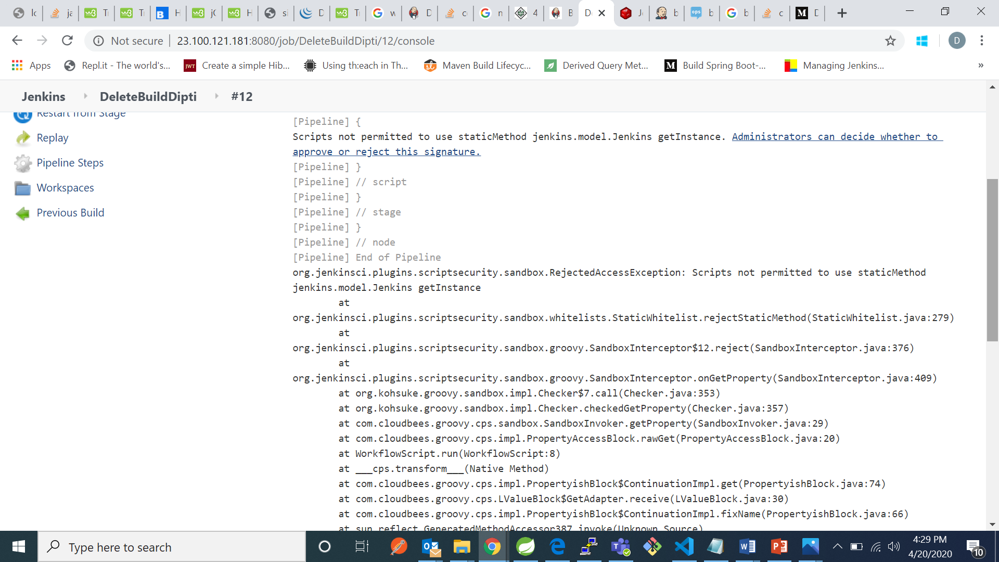

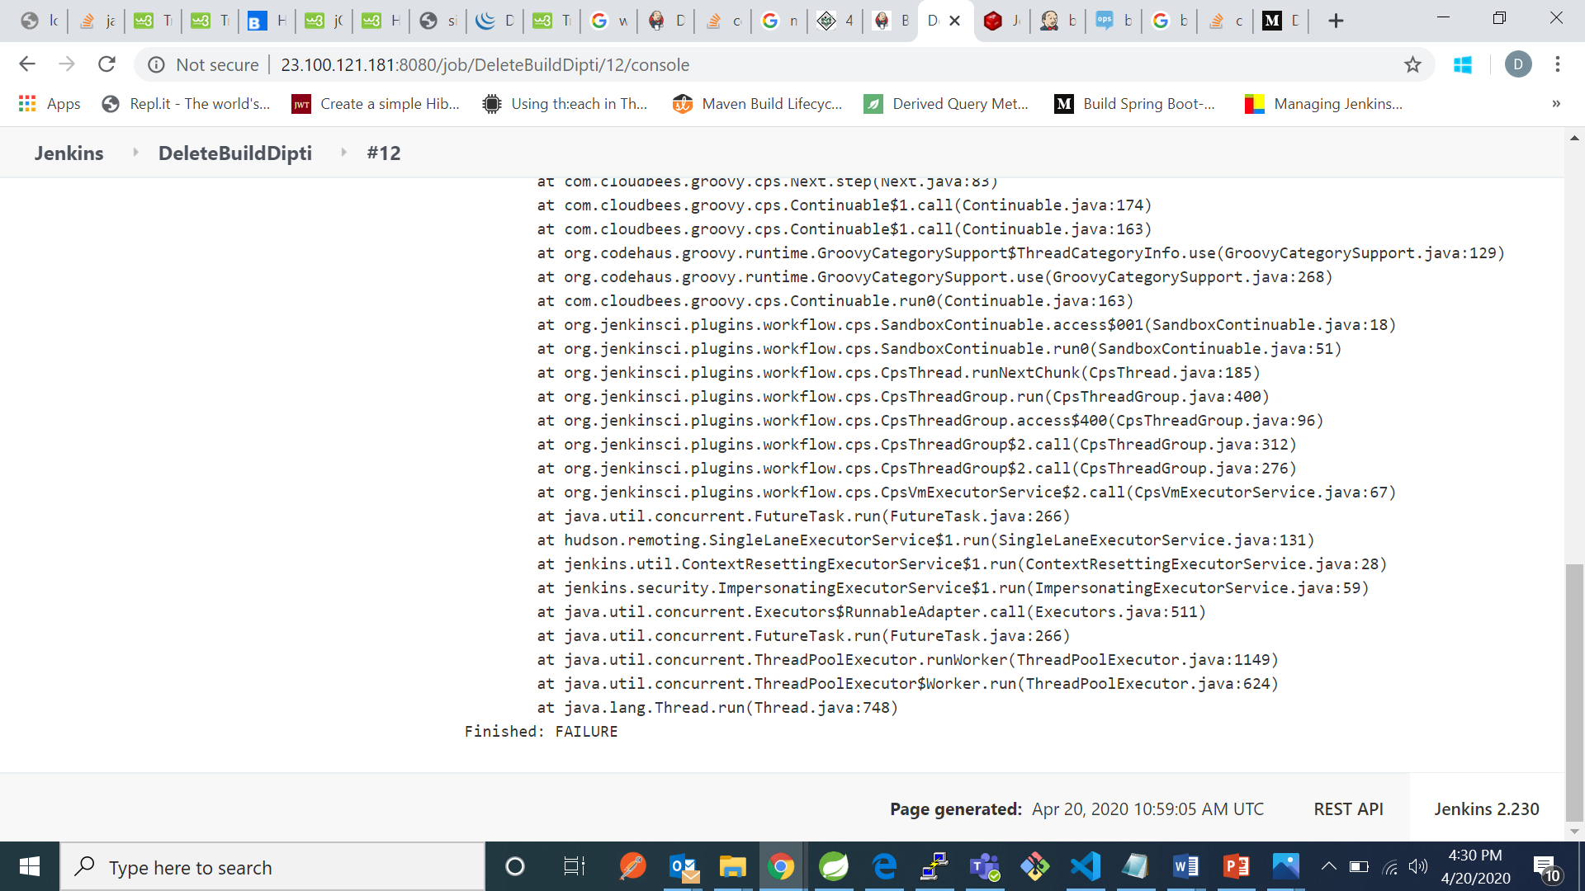

**Before clicking build now:** 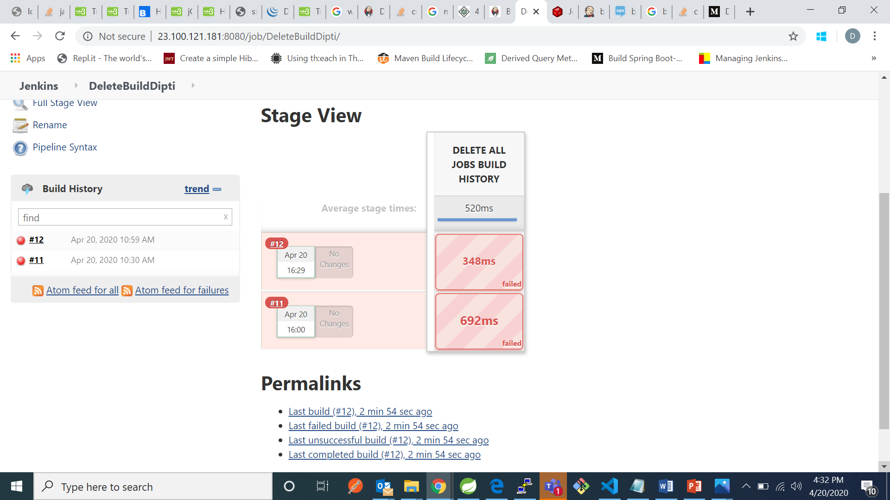

**After clicking build now**

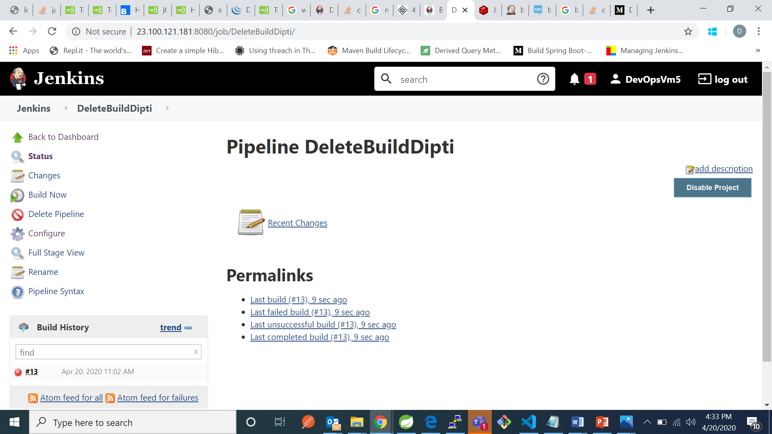

We can see only one of the latest build is left.